The game of Snake I have developed is a simple take on the assignment task but one with some clever caveats.
As the game world is built, it generates a random number of obstacles chosen at random from a list of pre-generated objects and places them across the map. The idea is to keep them slightly off the edge so they will leave paths around the edges rather than blocking it, leaving the difficulty value from having to avoid both obstacles and game edges.
The fruit will spawn randomly, between strawberries, bananas and grapes which all have a different score value attached. They cannot spawn on top of any existing objects.
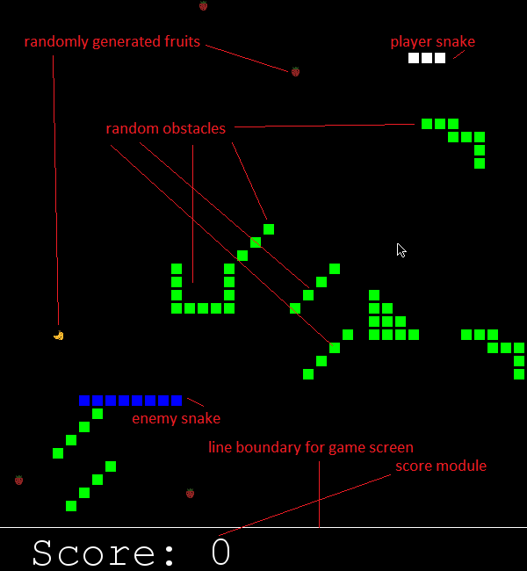
The game is over when the player crashes into either the wall: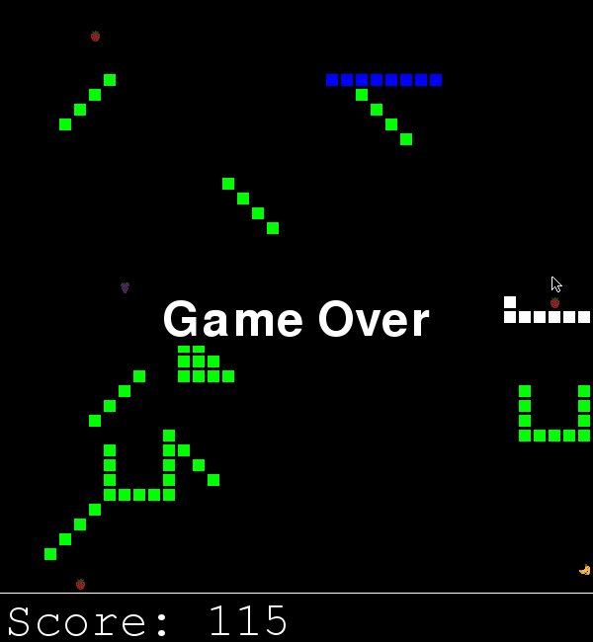

An obstacle:
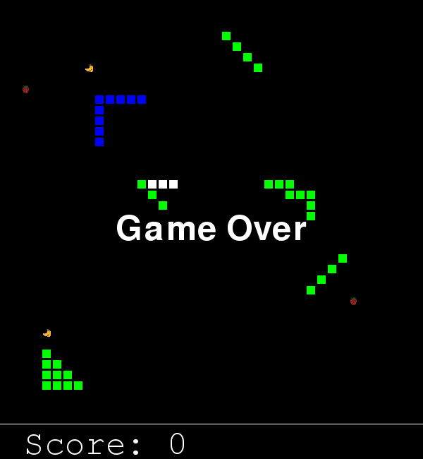

The enemy snake:
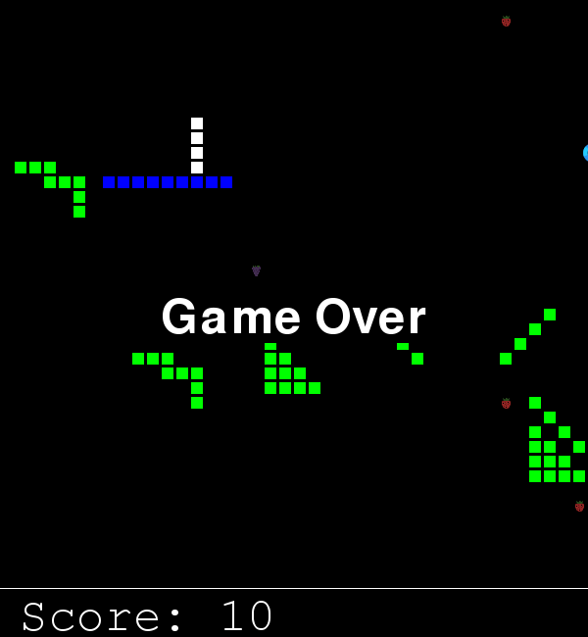
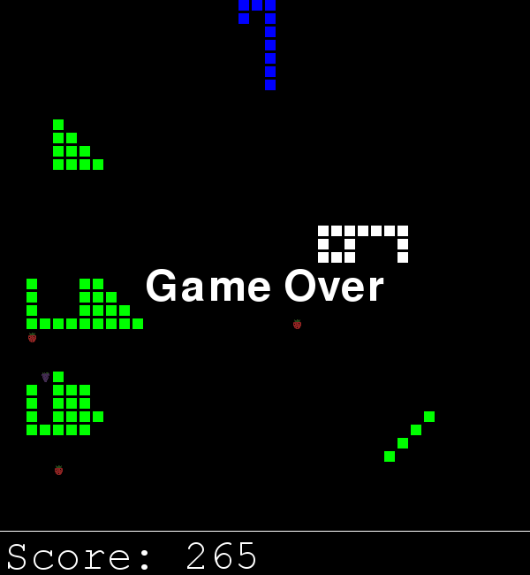
Or yourself:

It also features AI that regularly gets near the player and will steal food when it can:
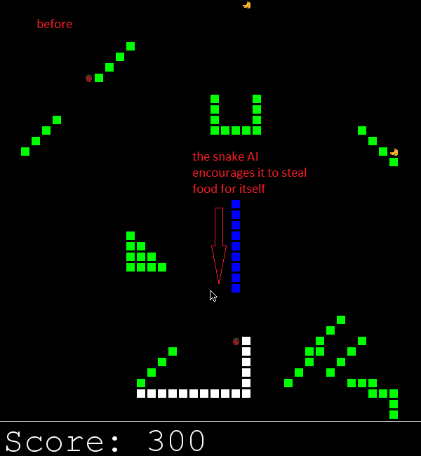
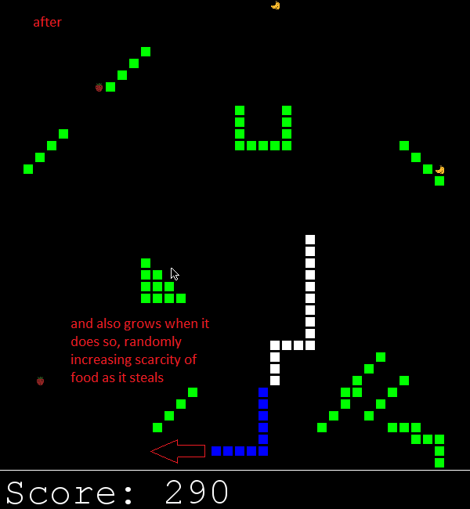 Which also reduces your score!

